What is cancer?
Contents
- What is cancer?
- What causes cancer
- Treating cancer
- Other ways of treating cancer
- Dr Kim says
What is cancer?
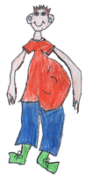
Our bodies are made up of millions of tiny cells. They all have different jobs to do and they are busy dividing (splitting into two), making more new cells to do their job, eg. new skin cells take the place of old skin cells, which are rubbed off the skin's surface when they die.
Usually new cells are made as they are needed in each part of the body. Inside each cell are chemicals that give the signals for making new cells or stopping making new cells.

Cancer forms when...
- the cells get their messages mixed up so that cells are made which are not normal cells, or
- the cells don't get a message to stop making new cells, so too many cells are made.
That is when a tumour forms.
- Some tumours are benign (say bee-nine). Too many new cells are made but they don't spread anywhere else.
- The other kind of tumour is malignant (say mal-ig-nant), and this is the cancer that grows too much in one area and can spread to other areas of the body.

What causes cancer
Anyone can get cancer, but some things may make it more likely to happen (called 'risk factors').
- 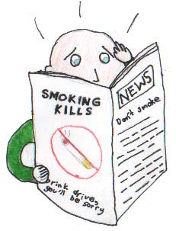
- Smoking can lead to lung cancer.
- Spending too much time in the sun can lead to skin cancer.
- Carcinogens (say car-sin-o-jens) - cancer-causing agents - in the environment can lead to cancer, eg. asbestos fibres and some chemicals used in some workplaces.
- Too much alcohol can lead to some types of cancer.
- A history of cancer in the family can mean that others are at higher risk (they are more likely to get cancer).
- People whose bodies do not have a strong immune system (the parts of the body that get rid of germs and body cells that are not normal) are more at risk of getting cancer. Some people with HIV/AIDS are more likely to get some cancers.

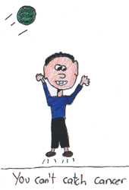 | However,  - often people who have many of these risk factors don't get cancer,  - while others who have none of these risk factors do.  Cancer can happen to anyone, and it's not anyone's fault if it does.

Treating cancer
Most cancers can be treated and often the person can get completely better, but sometimes treatment can only make someone better for a short time. Treatments often make people feel very sick for a while.
What treatment is used depends on the type of cancer and where it is.
- 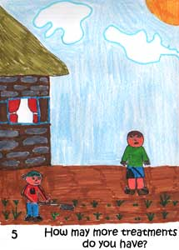
- Surgery, or having an operation to take out the tumour, can be used with some cancers. Sometimes other treatments are given as well as an operation.
- Radiotherapy is when high energy x-rays are aimed at the tumour to kill the cancer cells.
- Chemotherapy (say kee-mo-therapy) is when drugs are used to destroy the cancer cells. These drugs may also attack other healthy cells like the cells that make hair, and this is why people on this treatment often lose their hair - but it grows back again after the treatment stops.
- Hormone (hor-mown) therapy may block out hormones that cancers need to grow.
- With some cancers which make abnormal white blood cells (leukaemia - say lew-kee-mia), bone marrow transplants may be used. The person's own bone marrow cells need to be destroyed using chemicals, then they need to be replaced with the healthy bone marrow from another person, maybe someone else in the family.
- Immunotherapy (im-yoo-no-therpay) helps boost the person's immune system so that the body can fight the cancer itself.

Other ways of treating cancer
There are many other things which might help someone who has cancer. These things may help the person feel better, even if they do not stop the cancer from growing.
Many of them are about helping bodies and minds feel peaceful and happier so that the body may be more able to heal itself.
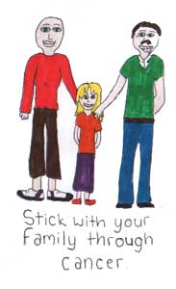
Some of these treatments are used at the same time as the treatments we talked about before.
- Meditation - where people learn to relax and think positive thoughts.
- Diets - where a nutritionist (say new-trish-on-ist) - an expert in what foods are best for us to eat - will help the person to find foods which will be healthy for them and to cut out foods which could make them feel ill or be hard to digest, particularly if they are having treatment.
- Counselling - where the person who is sick can talk through problems and ask questions. The person's family might find this helpful too.
- Exercise is a good way of helping someone feel better and is good for the body.

Dr Kim says:
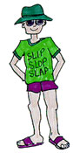

If someone you know has cancer then you can be helpful by understanding that he or she is still the same person. Take time to be with that person and understand that he or she will not want to talk about cancer all the time. Have fun together. Have a look at the topic 'Cancer - when someone you love has cancer'.
If the person is a close member of your family it can be very hard to deal with. Talk to your trusted adults about how you are feeling.
CanTeen, the Australian Organisation for Young People Living with Cancer, has a site for young people living with cancer https://www.canteen.org.au
Support people with cancer  Make them feel great  When they are in  a terrible state.  Take them out for a drink  Or give them a wink.  Make someone feel like  This is not the end  Because they are a special friend.  Samantha | 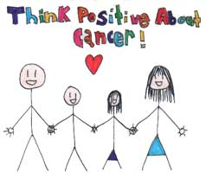
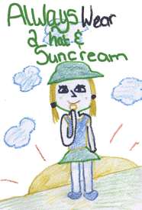
startFocuseekOmit

We've provided this information to help you to understand important things about staying healthy and happy. However, if you feel sick or unhappy, it is important to tell your mum or dad, a teacher or another grown-up.

